OPTICAL ILLUSIONS
Do Now Directions: Look at the image below What do you see? Write in your sketchbook if you do not have this worksheet.
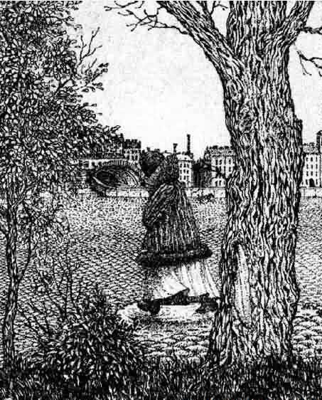
Answer the question: What do you see in this image? _______________________________________
__________________________________________________________________________________________
__________________________________________________________________________________________
__________________________________________________________________________________________
__________________________________________________________________________________________

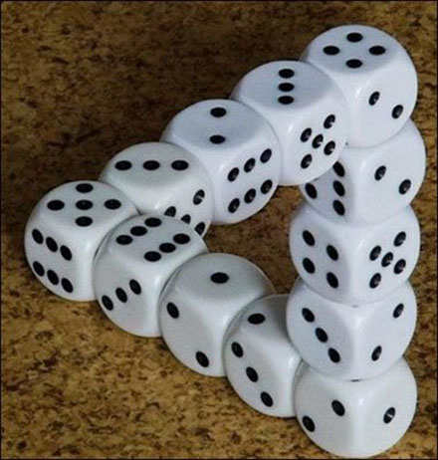
Do you see an illusion in this image?
Directions: Put your face really close to the above image, What do you see? _______________
_____________________________________________________________________________
Pull your face away from this image, Who do you see?________________________________

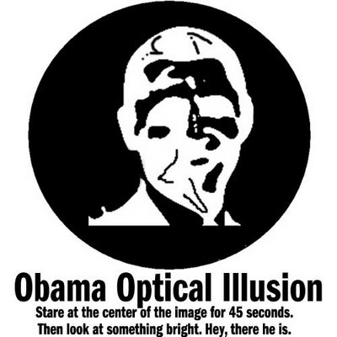
How do you think an image like this works? Do you see the same picture when you look away? What happens to the image?____________________________________________
_________________________________________________________________________
_________________________________________________________________________
_________________________________________________________________________
_________________________________________________________________________

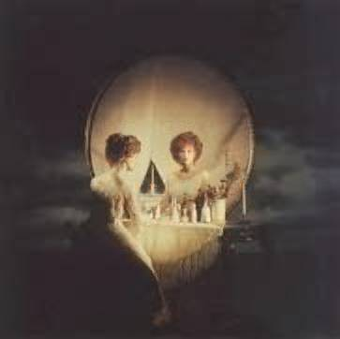
Directions: Answer the question, What do you see in this picture?________________________
_____________________________________________________________________________
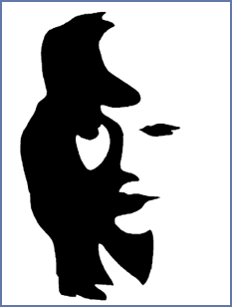
What do you see in this picture?_____________________________________________________________________________________________________
Let’s check this out on the big screen!

